Private Life of Chickens – BBC Name ____________________ 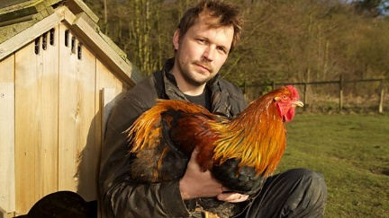
- How many species of bird have humans domesticated for food?

- What are some of the factors that determine the hierarchy (pecking order) in a flock of chickens?

- What happened to Dolly when she joined the captive flock of hens?

- What are the benefits to a species of having an established ‘pecking order?’

- Where were chickens first domesticated?

- How many breeds of chickens are there in the world?

- What part of the world do the wild ancestors of the chicken still survive in the wild?

- Why was the red jungle fowl selected as a species to be domesticated? The scientist lists several positive qualities.

- How did chickens respond to the stuffed fox?

- How do chickens primarily use their right eye?

What about their left eye?

- Could chickens discriminate between stars and circles in the experiment?

- How did the chickens respond to natural light and freedom for the first time?

- How did the hens respond to the introduction of Lloyd the rooster?

- How is it possible for a hen to ‘change gender’ and become a rooster?

