Nutrition Webquest Name ______________________________
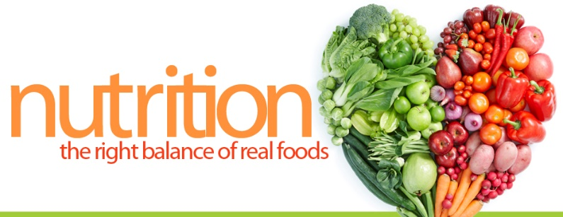
Go to Mr. Heath’s website: shaneheath.weebly.com
Under the “Courses” tab, select “Farm to Table” and use the appropriate web links to answer the following.

- Nutrition Data Website: Utilize the SEARCH feature of the website to fill in the following.
Food | Total Fat (g) | Total Fat  (% daily value) | Carbs (grams) | Carbs  (% daily value) | Protein (g) | Calories per serving | Is it high (>20% daily value) in any vitamins/minerals?
Cherry PopTart
Banana
Potato Chips BBQ
Black Beans
Subway Breakfast Steak and Egg
Grapes
Taco Bell Beef Burrito Supreme

Pick 3 foods of your own choosing and fill in the chart below using the nutrition data website.
Food | Total Fat (g) | Total Fat  (% daily value) | Carbs (grams) | Carbs  (% daily value) | Protein (g) | Calories per serving | Is it high (>20% daily value) in any vitamins/minerals?

Navigate to the Nutri-Links website (link on my class page)
Fill in the following chart by clicking on the appropriate vitamin/mineral. Bullets are okay.
 | Health Functions | Disease Risk Reduction
Vitamin A
Vitamin C
Vitamin D
Vitamin E
Lycopene
Calcium
Potassium
Iron

Click on the Food Guide Pyramid link and navigate through the pdf to answer the following questions.
- If someone told you that a baked potato and French fries are basically the same nutritionally because they’re both potatoes, how would you respond?

- Look at the table on page 9. Based on your specific daily caloric requirements (that you calculated in class) record how many servings of each food group are recommended for you?

b. How many grams of fat should you consume in a day?

- What is a serving? Give one example of what counts as a “serving” for each category.
Carbohydrate
Fruit
Vegetable
Dairy
Meat

- How much fat is there in a bologna and cheese sandwich (with mayo)?

- Are some types of FATS worse than others? Explain.

- What are some tips for reducing your intake of cholesterol?

- Look at the Table on Page 16. List 4 foods that have ZERO teaspoons of added sugar.

- From the same table, what are 4 foods that have 6+ teaspoons of added sugar?

- Even though some yogurt is listed as low-fat, does that mean you should eat a lot of it? Explain.

- What are 3 foods on page 18 that are especially high in salt?

