GMO Exit Ticket Name __________________
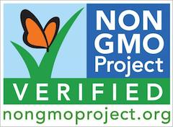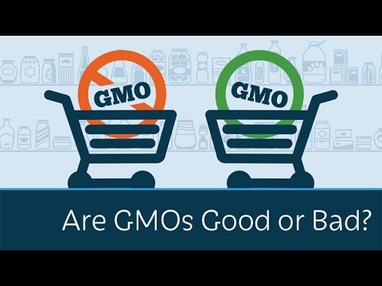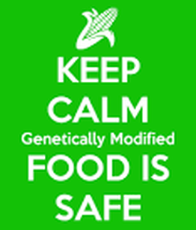
In a short paragraph, state whether or not you are presently in favor of or opposed to the growing of genetically modified crops, AND describe at least 3 lines of argument from the PBS website that support your opinion.

